(Approx. 586 words)

You may have a new speech recognition program
By Jerry Heaton, Editor, Central Kentucky Computer Society
May 2019 issue, CKCS Newsletter
www.ckcs.org
j.heaton (at) ckcs.org

I have used several speech recognition programs over the years. I have tried
them all, and suddenly a new one showed up on my computer and it is the best
one yet!

To provide you an example, all the text below the double line I dictated using the new
program.

After completing the dictation, I edited the text produced by my dictation following this
pattern:
- In the paragraphs below, all the black words are the result of my dictation.
- If I find a word I did not say, or a word misunderstood by MS speech recognition I
will change the black word to RED and draw a line through it.
- Any word I correct or added manually will be in GREEN which I typed.
- There were a couple of places improper grammar was substituted for what I said,
i.e. I said have and it entered had another time I said pay and it used paid, etc.

All the black text below was dictated.

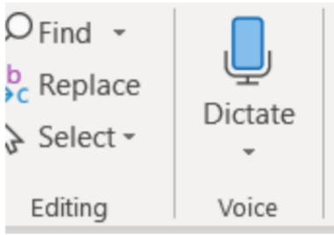
All of us using Windows 10 are very aware that periodically Micros oft updates the program and makes changes the way things are done. Maybe I should have said improvements and corrections instead of changes. Nonetheless, that happens. I am also a sub graber subscriber to Microsoft Office 365 for which I paid pay an annual fee and get periodic updates and corrections to it as well.

Today I wish to talk about a new feature that showed up unexpectedly on my Microsoft Word ribbon bar. Under the home tab they've added a section to the right labeled voice and it's a small microphone under which it says dictate.

Speech recognition is not new. The first demonstration I ever saw of it was about in
1990 4 1994 at a Compulex Show sponsored by CKCS in downtown Lexington at the
Convention Center. That product worked well at the show but those that bought the
program Were were greatly disappointed.

I have used speech recognition from time to time an and each time I've tried it, it's
better than before but those still proved to be more trouble then than it was worth
since it made multiple errors in understanding what I said and secondly the thought
process I used of producing text is not always in the order you would normally write
that text. In other words, I was not very skilled add at dictation.

This article is being dictated and I am not touching the keyboard for any part of it. For
speech recognition one should use a headset microphone. I had one of those but
have chosen to used use my microphone on my camera for this project. All I can say
is speech recognition program writers had have come a long long way since those
early days. This is working remarkably well.

We are on paragraph 5 and all of this has been dictated without touching the keyboard.

I have noticed that this new microphone icon at the right of the ribbon bar is also on
Microsoft’s outlook program which I use for email, as well as PowerPoint.

It is obvious that if one is interested in getting a lot of text quickly onto a page, speech
recognition is clearly the way to do that. The voice icon section was added by Microsoft Office 365

If you find the voice icon, give it a try.

